National Education DAY

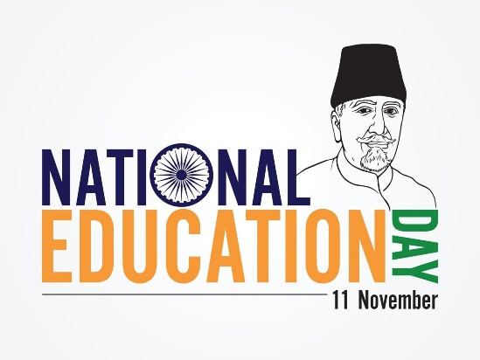

# Why do we celebrate “NATIONAL EDUCATION DAY”?

National Education Day is celebrated on November 11 every year in India to honor the birth anniversary of Maulana Abul Kalam Azad, the first Education Minister of independent India.This day highlights the importance of education in shaping India's future.

National Education Day is significant as it raises awareness of the value of education in society. It aims to motivate educators, students, and legislators to concentrate on developing a strong educational system that supports universal access to high-quality education. The day encourages a dedication to innovation and excellence in education by honoring Maulana Abul Kalam Azad’s efforts. It is a time to reflect on the challenges faced by the education sector and to strategize for improvements.

This day is crucial as it shows us where we can improve things. It serves as a kind of spotlight on the areas in which our educational system requires improvement. Additionally, it aids in assessing our progress toward the Sustainable Development Goal-4 (SDG 4). The main objective is to ensure that all children, regardless of their background, have the opportunity to receive a top-notch education and acquire new skills.

It all comes down to honoring the value of education! For every Indian, access to education is a fundamental right. It influences how our nation will develop in the future. Imagine having fantastic instructors and schools where all children, regardless of background, have the opportunity to learn. Ensuring that everyone has the opportunity to receive a top-notch education is the main goal of National Education Day

# Why is Education is important for us?

Education helps us to teach necessary morals, good manners, and wise ethics to others. As well as being good at the physical, mental and social level,besides, it promotes the feeling of living a better life. A good education is constructive, which creates our future. This allows an individual to enhance his mental, physical and spiritual level. By offering knowledge of many areas, it makes us confident individuals. It's enough to say that education matters. Studies show that those educated are more likely to live longer, live healthier lives, and help strangers more.

While children are young, investing in different types of education ensures that they have a strong foundation. Good education is intended not only to get hard work and good results but to accomplish new things for the welfare of the whole human race. Not only does education allow us to study history, science, mathematics, geography, and other subjects, but it also teaches us how to deal with life's bad situations. Therefore, education is essential for a better future. Education not only means getting bookish knowledge but it involves you having knowledge that will help you to evolve as a better human and the one who can protect society from all the evils.

National **Education**

Day

11 November

